**OOP with Java Laboratory (22CSE36L)**

**Mini Project Report**

**Group No:** 12

**USN:** 4SO22CS082

**Name:** Lisha Dsouza

**Java Swing Registration-Login Application:**

An intuitive Java Swing application for user registration, login, and a fun quiz experience. Seamlessly register, login securely, and test your knowledge with an interactive quiz. Save user credentials and quiz results for easy access.

**How to Use:**

**1. Registration:**

- Click on the "Register" button.

- Enter your desired username, password, security question, and answer.

- Click "Register" to complete the registration process.

- The registered info will get saved into the txt file

**2. Login:**

- Enter your username and password.

- Click "Login" to access your account.

- The Application checks for the credentials in the txt file and if present then you can take the quiz otherwise its necessary for you to know the password hence choose ‘Forgot Password’.

**3. Forgot Password:**

- If you forget your password, click on the "Forgot Password?" button.

- Enter your username and answer the security question to retrieve your password.

**4. Take Quiz:**

- Upon logging in, click on the "Login" button to proceed.

- Answer the quiz questions.

- Click "Submit" to view your quiz score.

- The score you scored will get saved in the text file in the particular location saved that is result.txt

**Persistence:**

- Registered User Credentials: User registration information is securely saved and can be accessed anytime.

- Quiz Results: Your quiz scores are stored with your name for future reference.

**File Structure:**

- `LoginApp.java`: Main class for the login application.

- `User.java`: Class representing a user with registration information.

- `UserDatabase.java`: Class handling user data loading and saving.

- `ForgotPasswordApp.java`: Class for handling password retrieval.

- `OnlineTest.java`: Class for conducting the online quiz.

**Platform:**

Integrated Development Environment (IDE): The quiz application is developed using any Java-supported IDE, such as Eclipse.

**Summary:**

This application provides a comprehensive solution for user registration, login, and quiz participation, all implemented using Java Swing for a seamless user experience.

The Java Swing application serves as a comprehensive platform for user registration, login, and an engaging quiz experience, all while emphasizing data persistence and security. The following paragraphs delve deeper into each aspect of the application, elucidating its functionality and user interaction flow.



Fig 1: Registration Page

Upon initiation, users are greeted with the Registration Page (Fig 1), where they can effortlessly input their desired credentials, including username, password, security question, and answer. The intuitive interface guides users through the registration process, ensuring a seamless experience. Once submitted, the registration data is securely stored in a text file (Fig 3), establishing a foundation for subsequent login sessions.



Fig 2: Login Page

Transitioning to the Login Page (Fig 2), users are prompted to enter their registered username and password. To enhance usability, a "Show Password" button offers the option to reveal the password for verification. In case of forgotten passwords, users can employ the "Forgot Password?" feature, which prompts them to answer their security question to retrieve access. This robust authentication mechanism ensures the security of user accounts while facilitating easy access to the application.

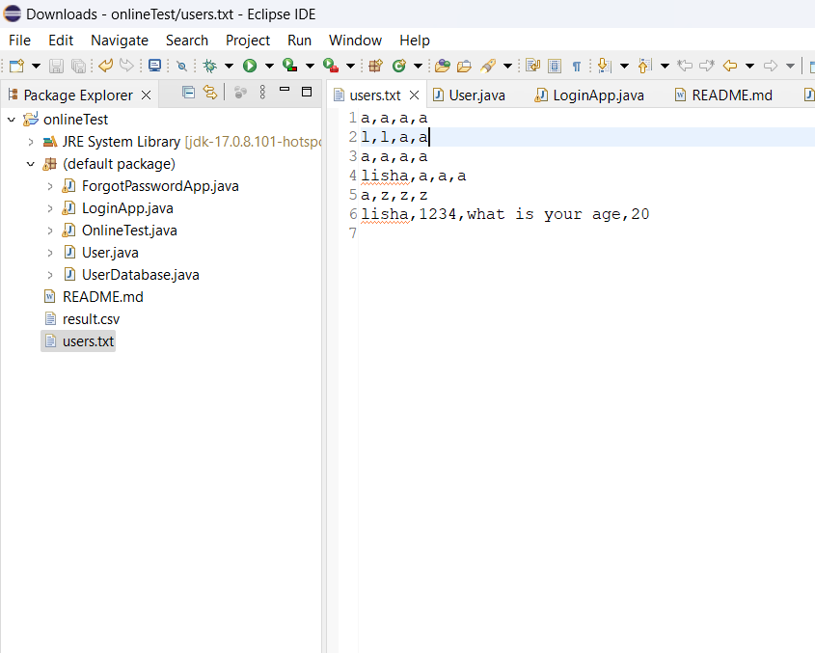

Fig 3: txt file saving the Registration data for login



Fig 4: Quiz Page

Upon successful login, users gain access to the main functionality of the application: the Quiz Page (Fig 4). Here, users are presented with a series of engaging quiz questions, along with multiple-choice options. To facilitate navigation and ease of use, navigation buttons such as "Previous" and "Next" allow users to traverse through questions seamlessly. Additionally, users can bookmark questions of interest for later review, enhancing the overall user experience.



Fig 5: Result Page

Upon completing the quiz, users are directed to the Result Page (Fig 5), where their quiz score is displayed alongside their name. The application then automatically saves this result in a CSV file named "result.csv," using a structured format that includes the user's name and quiz score. This data persistence feature ensures that users can track their quiz performance over time and facilitates easy retrieval of past results for analysis.